1 | 2 | 3 | 4 | 5 | 6 | 7 | 8 | 9 | 10 | 11 | 12
H |  | M |  | M

Syllabus for B. Tech I Year II semester
Information Technology
IT WORKSHOP and PYTHON PROGRAMMING LAB
Code: 8FC62
L | T | P/D | C
0 | 0 | 4 | 2

Course Objectives
Students will try to learn
- Basics of Python programming, Decision Making and Functions in Python, Object Oriented Programming using Python.
- To introduce to a personal computer and its basic peripherals, the process of assembling a personal computer, installation of system software like MS Windows, Linux and the required device drivers.

Course outcomes
Students will be able to
- Apply knowledge for computer assembling and software installation and ability to solve the trouble shooting problems.
- Apply the tools for preparation of PPT, Documentation and budget sheet etc.
- Install and run the Python interpreter, Create and execute Python programs.
- Apply the best features of mathematics, engineering and natural sciences to program real life problems.
- Describe the Numbers, Math functions, Strings, List, Tuples and Dictionaries in Python, Express different Decision Making statements and Functions, Interpret Object oriented programming in Python.
- Understand and summarize different File handling operations, explain how to design GUI Applications in Python.

IT Workshop
Week 1:
Introduction to Computer: Identify the peripherals of a computer, components/peripherals in a CPU & its functions. Introduction to the types of Operating System, Assembling and disassembling demonstration.

Week 2:
Install computer with dual boot operating system (Windows, Linux with PowerPoint presentation). Comparison of types of OS in different platform

Week3:
Introduction to S/W's, difference b/w hardware and software. Introduction to MS-Office and its importance.
Ms Word
Ms Power Point Presentation

Week4:
Introduction to Excel
Features: Accessing, Overview at toolbars, saving excel files, Gridlines, Format cells, Summation, Auto fill, formatting text.
Formula in excel – Average, Standard Deviation, Charts, Roaming & Inserting worksheets, Hyper linking, count function, lookup / Vlookup, sorting, Conditional formatting.

IT Workshop Lab

Week 1:
Identify the peripherals of a computer, components in a CPU and its functions. Draw the block diagram of the CPU along with the configuration of each peripheral and submit to your instructor
AIM: To identify the peripherals of a computer.
- The Mother Board
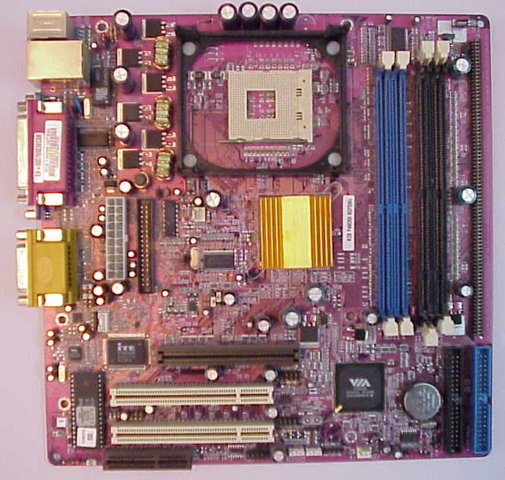

2. CPU (Processor)

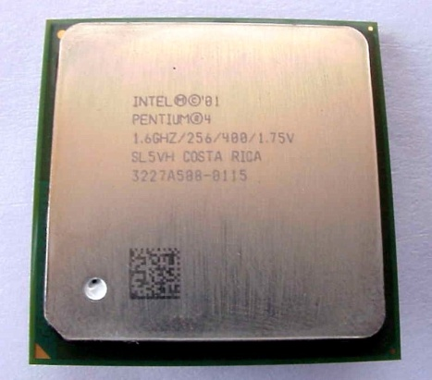

3. SMPS(Switched mode Power Supply)

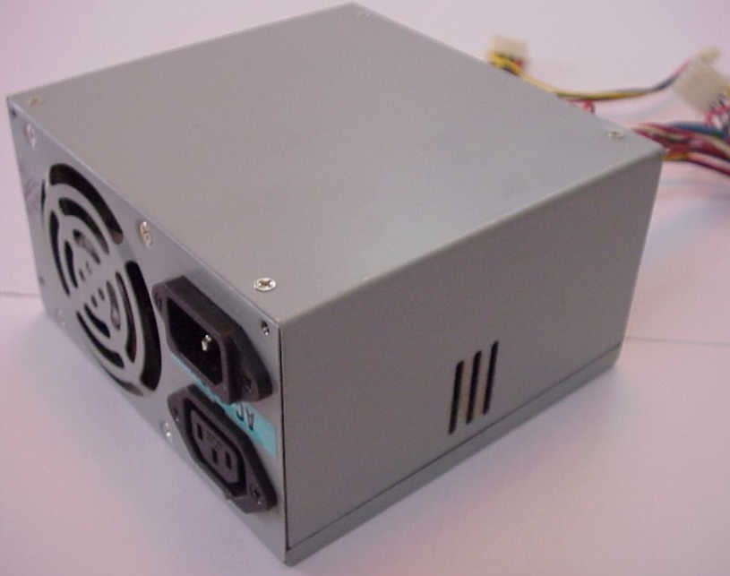

4. Cabinet
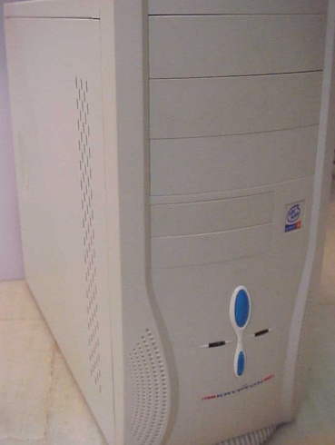

5. CPU heat Sink and fan
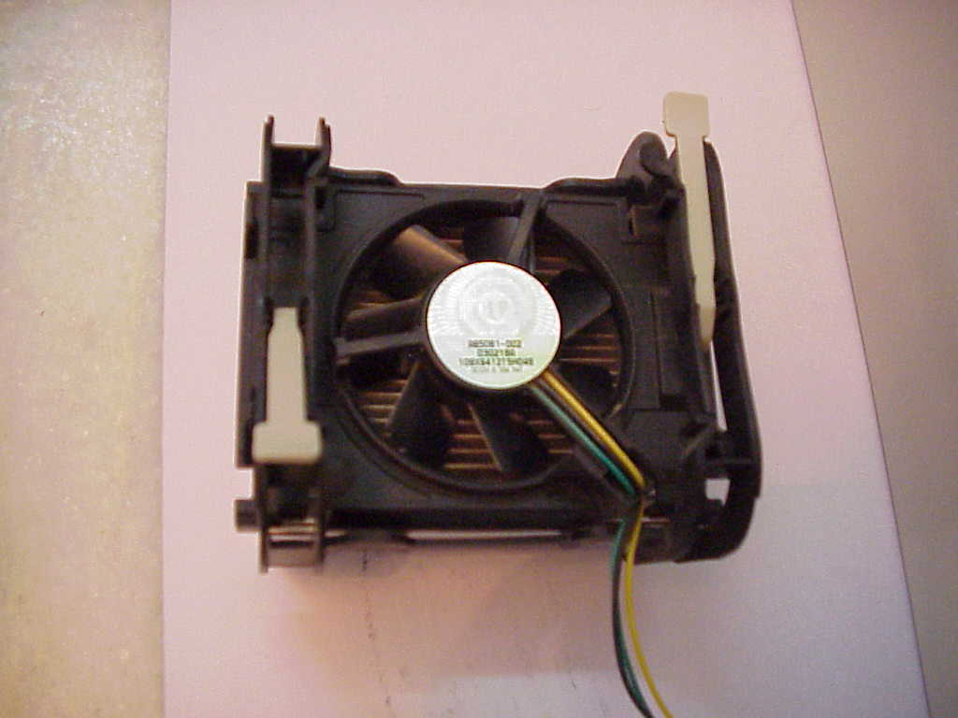

6. RAM (Random Access Memory)
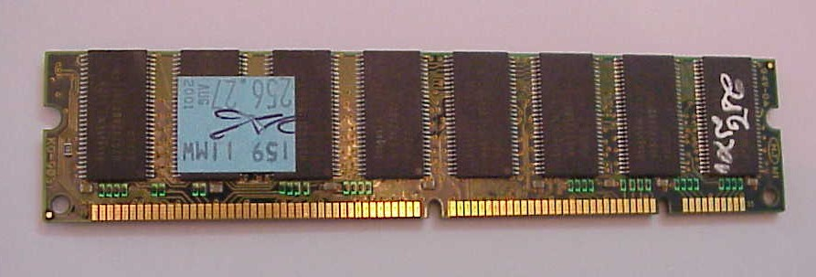

7. HDD (Hard Disk Drive)
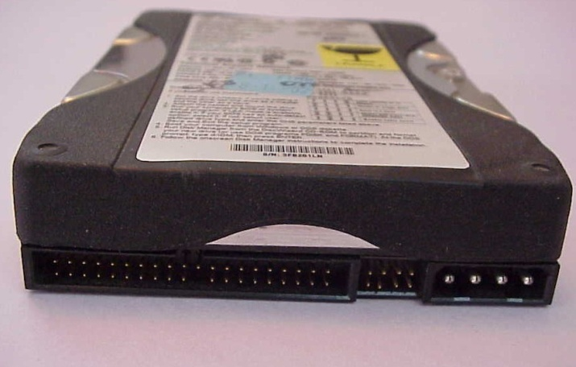

8. FDD (Floppy Disk Drive)
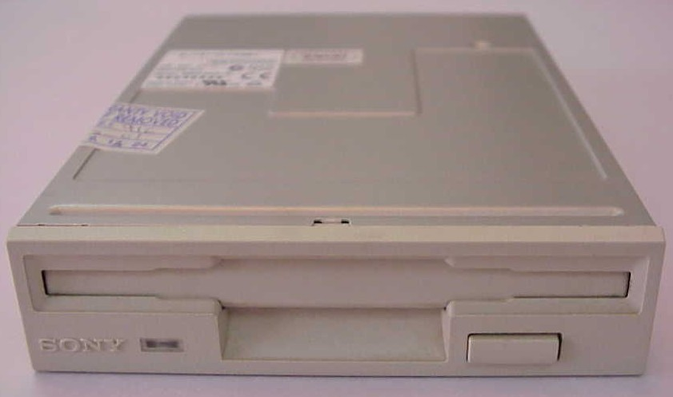
9. CD-ROM Drive
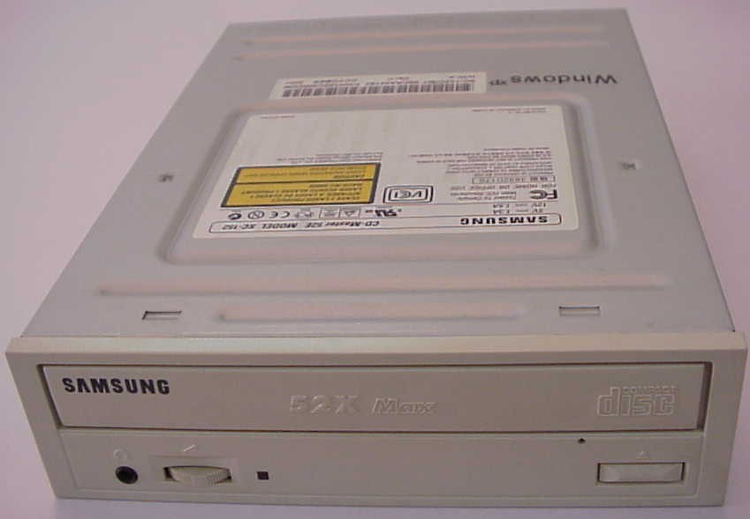

10. CD Writer
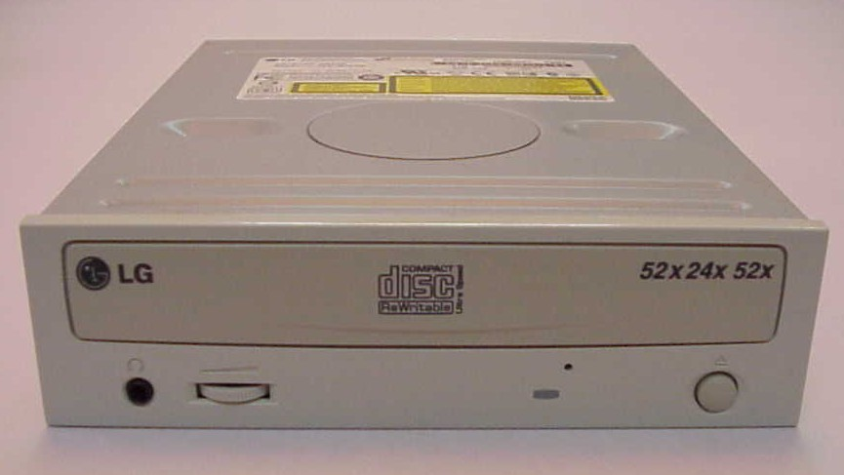

11 Different Screws Used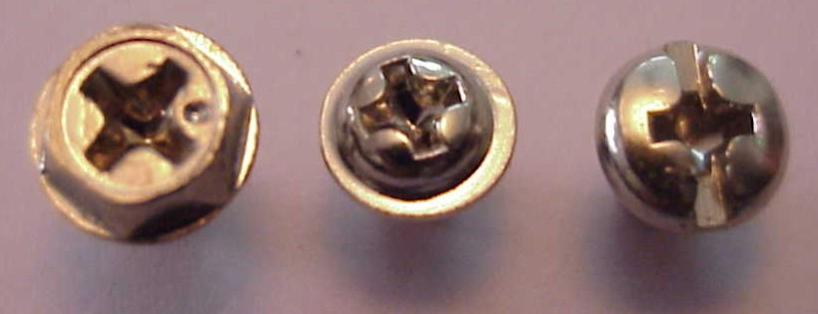

2. AGP (Accelerated Graphics Port) Card
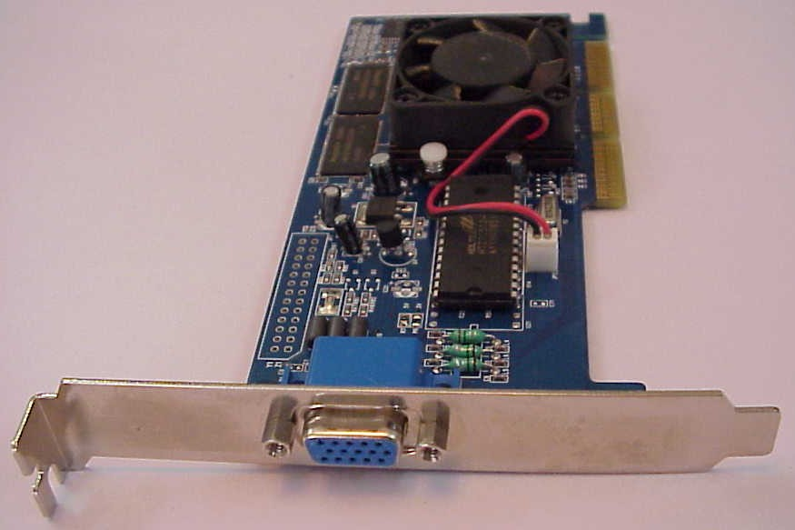

13. LAN (Local Area Network) card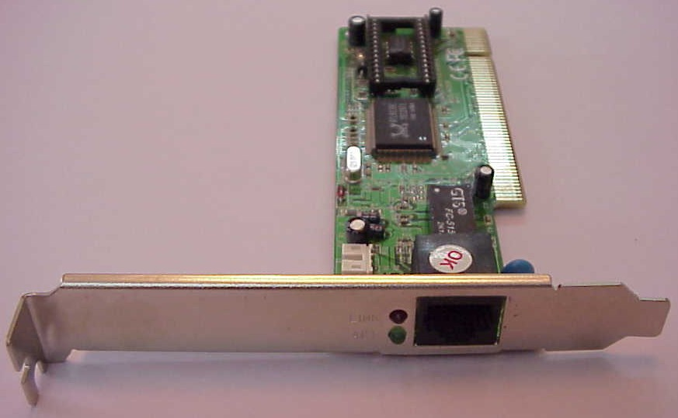

THE MOTHER BOARD
Socket 478
North Bridge
DDR RAM Slots
SD RAM Slots
South Bridge
PCI Slots
AGP Slot
BIOS
ATX Power Connector
Floppy Drive Connector
Primary Secondary
CMOS Battery
Ports
Steps for Assembling.

- Setting the cabinet ready.
- Preparing to fit the components.
- Fitting the mother board.
- Fitting the RAM, processor and cooler.
- Installing PCI cards.
- Fitting the hard disk and floppy drive.
- Installing the CD ROM drives.
- Connecting the ribbon cables.
- Powering the drives and mother board.
- Connecting the cables for the case front panel.
- Final check.
Getting the Cabinet ready:-
- Check how to open the cabinet and determine where to fix the components.
- Determine if the case has the appropriate risers installed.
Preparing to fit the Components:
- Network adapter drive.
- Floppy disk drive.
- Ribbon cables.
- Hard disk.
- CD-ROM Drive.
- RAM
- CPU
- Heat sink / cooler / fan.
- Mother board.
- Screws.
Fitting the Mother board.
- Line up the patch on the motherboard ( ps/l, USB, etc ) with the appropriate holes in the block panel I/O shield of the case.
- Check the points where you and to install
- Install them and make the mother board sit on them and fix screws if required.
Mother board parts:
- ACR slot.
- PCI Slot.
- AGP Slot.
- ATX Connectors.
- CPU Fan.
- Chipset North Bridge.
- CPU socket.
- Floppy.
- System memory.
- Chipset south bridge.
- Panel connector.
- Power supply.
- IDE connectors.
ATX Connectors:
- PS, Mouse.
- Key board.
- USB.
- Parallel ( Prints )
- Serial COM1.
- Serial COM 2.
- Joystick.
- Sound.

Fitting the processor:
1. Raise the small lever at the side of the socket.
2. Notice that there is a pin missing at one corner, determine the direction to fit in the processor.
- You should not force the CPU. When inserting it. All pins should slide smoothly into the socket.
- Lock the lever back down.
- Install the heat sink over it (Different type for each processor). Heat sink / CPU fan.
Fitting the RAM:
- The RAM must be suitable for motherboard.
- There are currently 3 types of RAM available.
    - SD RAM.
    - DDR SD RAM.
    - RD RAM.
- The mother board’s chipset determines which type of RAM may be used.
Installing the PCI Cards:
- Most of the cards are inbuilt these days.
- NIL, Sound Cards etc. are fitted into PCI slots.
Fitting the hard disk and Floppy disk:
- Place the floppy and hard disks in their slots.
- Leave some space above HDD to prevent heat building.
- Check the jumper configuration.
- Fix the screws.
Installing the CD-ROM Drives:
- CD-ROM drive is similar to installing a hard disk.
- 1ST check that the jumper configuration is correct.
- Fix the screw.

Connecting the ribbon Cables:-
- Attach the long end of the cable to the IDEU connector on the motherboard first.
- The red stripe on the IDE cable should be facing the CD Power.
Powering the driver and motherboard:
Connecting the cables for the case front pane
1. SD, SPK or SPEAK: The loud speakers o/p. it has 4 pins.
2. RS, RE, RS or RESET: Connect the two pin Reset cable here.
3. PWR, PW, PWSW, PS or power SW: Power switch, the pc’s on (switch, the plug is two pin ).
4. PWLED, PWRLED or Power LED: The light emitting diode on the front panel of the case illuminates when the computer is switched on. It’s a 2-pin cable.
5. HD, HDD, and LED: These two pins connect to the cable for the hard disk activity LED.
Final Check:-
- Mother board jumper configurations are the settings for the processor operator.
- Drive jumper settings, master/ slave correct?
- Are the processor, RAM modules and plug in cards finally seated in there sockets?
- Did you plug all the cables in? Do they all fit really?
- Have you frightened all the screws in plug- in cards or fitted the clips?
- Are the drive secure?
- Have u connected the power cables to all driver?

Powering up for the first time:
- Ensure that no wires are touching the CPU heat sink fan.
- Plug your monitor, mouse and keyboard.
- Plug in power card and switch the power supply.
- If everything is connected as it should be
- All system, fans should start spinning.
- U should hear a single beep and after about 5-10 sec.
- Amber light on monitor should go green.
- You will see computer start to boot with a memory check.
- Now check front LED’S to see if u plugged them in correctly.
- Check all other buttons.
- Power afford change any wrong settings.

Viva Questions:

- Define a computer?
- Define hardware and software?
- What are the functional units of a computer?
- Define the following: RAM,ROM,BIOS,BUS,BIT,PROGRAM.
- What is the use of a mother board?
- Define assembling of a system?
- Explain the steps involved in the installation of the mother board>
- What is the use of pin 1 indicated on the processor?
- What is the use of locking level at the processor slot?
- Define a port?

Week 2:
AIM: To install Windows XP

Procedure:

- keep on press the delete button and go to advanced BIOS feature. [ BIOS- Basic Input Output System ]
- And go to boot sequence. Select first boot drivers. CD ROM and press F10 to save the bios feature. Yes and then enter. Press any key to boot from CD. Press enter to setup windows XP.
F8 = To agree the license.
- Press ESC to don’t repair the windows XP setup.
- Press ‘p’ to delete the previous partitions. Then press enter.
- Press ‘L’ to delete the partition.
- Press ‘C’ to create the partition in the un partition space.
- Press enter to setup windows XP on the selected items.

BASIC FILE SYSTEMS:

FAT: File Allocation Table.
NTFS: New Technology File System.
Format the create using NTFS partition
BASIC STEPS IN INSTALLATION:-
- Collecting information.
- Dynamic update.
- Preparing installation
- Installing windows.
- Tracking installation.
Select the language as English (united status), then ok.
Enter your name and organization.
Enter the product key.
Enter the computer name and give password (if necessary) then ok.
Then select the date and time.
Then select the typical setting.

AIM: To install Linux in system
Procedure:
1. Language Selection
- Using your mouse select the language you would prefer to use for the installation
- Click next to continue.
2. Key Board Configuration:
- Using your mouse select the correct layout type for the keyboard you would prefer to use for the installation and as the system default.
- Once you have made the selection click next to continue.
3. Mouse Configuration:
- If you have a PS/2 ,USB or Bus mouse you do not need to pick a port and device. If you have a serial mouse, you should choose the correct port and device that your serial mouse is on.
- The Emulate 3 buttons checkbox allows you to use a two-button mouse as if it had three buttons. If you select this check box you can emulate a third “middle” button by pressing both mouse buttons simultaneously.
4. Installation Type:
- Choose the type of installation you would like to perform.
- Your options are Personal desktop, Workstation, Server, Custom and upgrade
5.Disk partition Setup:
- You can chose automatic partitioning or manual partitioning using Disk Druid of fdisk.
- Automatic partitioning allows you to perform an installation without having to partition your drives yourself.
- Automatic partitioning allows you to have some control concerning what data is removed from your system.
- Your options are:
  - Remove all Linux partitions on this system.
  - Remove all partitions on this system
  - Keep all partitions and use existing free space.
- To partition manually choose either Disk druid or fdisk partitioning tool.
- Lick next once you have made your selections.
5.Partitioning your system:
- If you chose automatic partitioning and did not select Review skip ahead
- If you choose automatic partitioning and selected review you can either accept the current partition settings(click next) or modify the setup using Disk Druid, the manual partition tool.
- If you choose manual partition with fdisk skip ahead.
- At this point you must tell the installation program where to install Linux. This is done by defining mount points for one or more disk partitions in which Linux will be installed.
6.Adding Partitions:
- To add a new partition select new button ,a dialogue box appears.
- Select the options and click ok
7.Boot Loader Configuration:
- Boot loader is the first software program that runs when a computer starts.
- The installation program provides two boot loaders GRUB ( GR and Unified Boot Loader) which is the default and LILO
- If you do not want GRUB as your boot loader click Change Boot Loader.
- You can then choose to install LILO or choose not to install boot loader at all by clicking Do not install boot loader on the change boot loader button.
- Network devices are automatically detected and displayed in Network Devices list,
- Select a network device and click Edit
- Here you can configure IP address and net mask of the device.
8.Firewall configuration:
- Offers firewall protection for enhanced protection.
- A properly configured firewall can greatly increase the security of the sysyem.
9.Time zone configuration:
You can set your time zone by selecting your computers physical location or by specifying your time zones offset from Universal Time.
10.Account Configuration:
- Allows to set Root password or user accounts
- Root count is similar to the administrator password that you set up in Win NT.
- Click add button to add a new non-rot user.
- Enter the details and click OK.
11.Packing group selection:
You can select package groups which groups components together or individual packages or a combination of the two.
Viva Questions:
- NTFS stands for---------?
- What is the use of product key in the installation process of a software?
- How many characters does a product key contain fro windows XP?
- Describe different kinds of Microsoft Operating systems?
- What are the pre-arrangements for installing the windows OS?
- Give the advantages of Linux over other OS?
- What do you mean by open source OS?
- What are the commands used to make disk partitioning manually in Linux OS?
- What do you mean by dual boot systems?
- Which type of file systems are required to install hard disk at the time of installation of Linux OS?

Week3:

Difference between Hardware and Software
Hardware
It refers to any physical component of computer. Hardware is the part of the computer that we can touch and feel. It is made up of interconnected electronic devices that control the operations of the computer.
A computer system has the following hardware components:
Motherboard, Input Devices, Output Devices, Storage Devices, Cards, Ports and Cords, Power Supply, Processor, Memory.
Software
It refers to the programs to run the computer. Software is a group of instructions that tell the hardware what to do. These instructions are also called ‘programs’.
Ex: Ms Outlook Express, ASP, VB, Java, MS Office etc.

Microsoft Office and its Tools

Office Tools is a set of several tools like Word, Excel, and PowerPoint etc.
MS Word -> used for word processing
MS Excel -> used for calculation and analysis of data
MS PowerPoint -> used for business and technical presentations

Ms Word
INTRODUCTION TO MS-WORD
Let us consider an office scene. Many letters are typed in the office. The officer dictates a letter. The typist first types a draft copy of the letter. The officer goes through it to check mistakes regarding spelling errors, missing words, etc. and suggests corrections. The typist changes the letter as suggested by the officer. This is a simple example of word processing.
There are many software packages to do the job of word processing. Some of them work in DOS environment. Example are WordStar, Word Perfect and Professional Write. But in these days working in WINDOWS is becoming more and more popular. So let us consider software for word processing which works in WINDOWS. Our choice is MS-WORD because it is the most popular software in these days.
MS-WORD is a part of the bigger package called MS OFFICE, which can do much more than word processing. In fact when you open up MS OFFICE you will find four main components in it. They are MS-WORD (for word processing), MS EXCEL (for spreadsheet), MS ACCESS (for database management) and MS POWERPOINT (for presentation purposes). However, we will limit ourselves to MS-WORD only in this lesson.

Objectives
After going through this lesson you should be in a position to
- start the MS-WORD package
- be familiar with the MS-WORD screen
- advantages and Features of Word Processing
- some common Word Processing Packages
- how to invoke Ms-Word
- learn the capabilities of Ms-Word
What is Word-Processing?
Word Processor is a Software package that enables you to create, edit, print and save documents for future retrieval and reference. Creating a document involves typing by using a keyboard and saving it. Editing a document involves correcting the spelling mistakes, if any, deleting or moving words sentences or paragraphs.
(a) Advantages of Word Processing
One of the main advantages of a word processor over a conventional typewriter is that a word processor enables you to make changes to a document without retyping the entire document.

(b) Features of Word Processing
Most Word Processor available today allows more than just creating and editing documents. They have wide range of other tools and functions, which are used in formatting the documents. The following are the main features of a Word Processor
- Text is typing into the computer, which allows alterations to be made easily.
- Words and sentences can be inserted, amended or deleted.
- Paragraphs or text can be copied /moved throughout the document.
- Margins and page length can be adjusted as desired.
- Spelling can be checked and modified through the spell check facility.
- Multiple document/files can be merged.
- Multiple copies of letters can be generated with different addresses through the mail-merge facility.
(c) Some Common Word Processing Packages
The followings are examples of some popular word processor available
- Softword
- WordStar
- Word perfect
- Microsoft word
Important Features of MS-WORD
Ms-Word not only supports word processing features but also DTP features. Some of the important features of Ms-Word are listed below:
- Using word you can create the document and edit them later, as and when required, by adding more text, modifying the existing text, deleting/moving some part of it.
- Changing the size of the margins can reformat complete document or part of text.
- Font size and type of fonts can also be changed. Page numbers and Header and Footer can be included.
- Spelling can be checked and correction can be made automatically in the entire document. Word count and other statistics can be generated.
- Text can be formatted in columnar style as we see in the newspaper. Text boxes can be made.
- Tables can be made and included in the text.
- Word also allows the user to mix the graphical pictures with the text. Graphical pictures can either be created in word itself or can be imported from outside like from Clip Art Gallery.
- Word also provides the mail-merge facility.
- Word also has the facility of macros. Macros can be either attached to some function/special keys or to a tool bar or to a menu.
- It also provides online help of any option.

Getting Started With MS-WORD
We have already told you that for working in Ms-Word you should be familiar with WINDOWS. If you have not covered WINDOWS so far then read that first and then go through MS-WORD. By now you must be aware of the fact that a software package is improved from time to time. These improvements are sold in the market as new versions of the same software. Thus you will find many versions of MS-WORD being used in different offices. In this lesson we will cover the version MS-WORD 97, which is latest in the market and contain many improvements over the older versions. However, you do not have to worry if you have an older version such as WORD 6.0 or WORD 95. All the commands available in these older versions are also available in WORD 97 and they are compatible.
While working in MS-WORD you have to work with a mouse. Also one can work, to some extent, through the keyboard. The use of mouse is simpler as it is fully menu driven. In MS-WORD every command is available in the form of ‘icons’.
Let us discuss the important components of the screen.
- Title Bar
The title bar displays the name of the currently active word document. Like other WINDOWS applications, it can be used to alter the size and location of the word window.
- Tool Bars
Word has a number of tool bars that help you perform task faster and with great ease. Two of the most commonly tool bars are the formatting tool bar and the standard tool bar. These two toolbars are displayed just below the title bar. At any point of time any tool bar can be made ON or OFF through the tool bar option of View Menu.
c. Ruler Bar
The Ruler Bar allows you to format the vertical alignment of text in a document.
d. Status Bar
The Status Bar displays information about the currently active document. This includes the page number that you are working, the column and line number of the cursor position and so on.
e. Scroll Bar
The Scroll Bar helps you scroll the content or body of document. You can do so by moving the elevator button along the scroll bar, or by click in on the buttons with the arrow marked on them to move up and down and left and right of a page.
f. Workspace
The Workspace is the area in the document window were you enter/type the text of your document.

g. Main Menu
The Word main menu is displayed at the top of the screen as shown in the Fig. 9.1. The main menu further displays a sub menu. Some of the options are highlighted options and some of them appear as faded options. At any time, only highlighted options can be executed, faded options are not applicable. Infect if the option is faded you will not be able to choose it. You may not that any option faded under present situation may become highlighted under different situations.
Starting MS Word
Click on Start -> Programs -> Microsoft Word
Major operations of MS Word
1. Create, open, save and print the documents.
2. Typing, editing, cut, copy, paste and justify the text.
3. Spell check & grammatical errors.
4. Format the paragraphs.
5. Create & manipulate tables.
6. Using Spell-checker.
7. Page setup, paper size, margin, header, footer, page numbering.
8. Word count.
Ms Power Point Presentation

Introduction:
Microsoft PowerPoint is a software product used to perform computer-based presentations. There are various circumstances in which a presentation is made: teaching a class, introducing a product to sell, explaining an organizational structure, etc.
There are two main kinds of presentations you can deliver: before an audience or not. The preparation and the actual delivery of each are quite different. Before getting into the details of each, we will first take a look at the software and analyze what it has to offer.
Starting Microsoft PowerPoint
- To use Microsoft PowerPoint, you must first open it:
One way you can open Microsoft PowerPoint by clicking Start -> (All) Programs -> Microsoft Office Microsoft Office PowerPoint.
- Sometimes somebody may send you a Microsoft PowerPoint presentation as an E-Mail attachment, a file on a floppy disk, or a file on the network, etc. The file is usually represented by a Microsoft PowerPoint icon. You can double-click the icon to launch Microsoft PowerPoint and immediately open the presentation.
- You can open Microsoft PowerPoint using a shortcut. If you happen to use the software on a regular basis, you can create a shortcut on your desktop or on the Quick Launch area. Many users also take advantage of the Microsoft Office Shortcut Bar. Sometimes, the icon you need will not be there; in that case you should insert it manually.
- If you are working on a network of related computers, a presentation may be located in another computer. Once you locate the computer or the folder on the network and you see the Microsoft PowerPoint icon, you can double-click it. This would open the application and the presentation. The network administrator can also create a link or shortcut to the drive that is hosting the presentation. You can then click or double-click this link or shortcut to open the presentation and, as a result, launch Microsoft PowerPoint.

Creating a New Presentation
Shows the opening window that you see when you start PowerPoint and begin a new presentation. If you close the Slide and Outline tabs window on the left side of the screen, you gain more room to work on the individual presentation slides that appear in the center of the screen.
Select the New Presentation task pane by clicking the task pane's down arrow and selecting New Presentation. This task pane includes an option under the New section labeled From Design Template. Instead of starting to work right away on a blank (and generic) presentation, you can click the option to choose from one of many predefined presentation templates. Click the option now to see your New Presentation task pane change to the Slide Design task pane as shown in The task pane displays a list of many presentation style choices, all defined by templates. The idea is that you find the style you like and click that style, and your presentation's elements such as headings, background artwork, and fonts all have a uniform appearance and tone.

Creating Presentations Using Design Templates
As you learned in this lesson's first section, you can begin working on your presentation's first slide the moment you start PowerPoint. Instead of letting the AutoContent Wizard generate a sample presentation, you can select from one of the templates to get your presentation started with a design and then add slides as you create your presentation using the same template so that your presentation maintains a uniform appearance.

Note
If you click the toolbar's New button, PowerPoint does not open the New Presentation task pane but begins a new presentation with a blank slide and the Slide Layout task pane, as Figure 11.5 shows. The presentation often includes placeholders that you can use to enter your presentation's content. You can choose from among the layouts to generate each slide's look. You won't have the uniformity throughout your presentation that a template would give you, but at the same time you have more flexibility to create exactly the look you require.
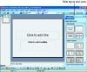
Figure 11.5 You can forgo the AutoContent Wizard and templates and add slides that fit any layout.
When you finish with a slide and you are ready to add the next one, click the New Slide toolbar button and PowerPoint adds a blank slide to your presentation and presents the Slide Layout task pane once more. A presentation contains one or more slides, so you need to click the New Slide button every time you are ready to add the next slide to your presentation.
You can change the template design at any point while you're developing your presentation. To do so, just click the toolbar's Design button and the templates appear in the Slide Design task pane. When you select a template, PowerPoint converts your entire presentation to that template's format. Each slide's background image and standard text such as headings and footers then take on a uniform appearance. If you click another template, PowerPoint converts the entire presentation once again to that new template. You can experiment with different templates to see which, if any, match the tone of presentation you want to achieve.
The instructions on the template's generated slide, as shown in Figure 11.6, indicate what to do next
These preset areas on each slide (placeholders) are designed to accept various kinds of data and make entering information on slides a snap. For example, you can click in a text placeholder and then type your text. In most cases, you edit the text, possibly change colors, and perhaps add a graphic image to the slide. Placeholders help you more easily do this.
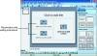
Figure 11.6 The template's placeholders provide instructions you follow to create a unique slide.
After you add the presentation's final slide, you can save your presentation. You can save the presentation in PowerPoint format or in HTML for embedding into Web pages. Even if your presentation has video and other multimedia content, you can save the presentation as a Web page for viewing from a browser.
You can save a presentation in much the same way as you save a file in Word or Excel. Choose File, Save As and then specify a name for your presentation. PowerPoint automatically adds the filename extension .ppt to your presentation's file.

Note
As you can see, if you start out designing your own slides without the use of a template, you can, at any time later, apply one of the template styles to the slide. Therefore, if you don't like what you generate from scratch, you can redesign the slide or entire presentation without re-entering the slide's text. If you save a presentation as a template file, you can use that presentation's format for subsequent presentations.

Note
Without a template to get you started, presentations require that you manually create every slide element, including the text, titles, and body. Most slides have a title and text, and many have a graphic image. Why not let the AutoContent Wizard or the templates start things off right? The predefined slides work for so many purposes. Resist the temptation to create your slides from scratch until you acquaint yourself with the predefined slides. In most cases, the AutoContent Wizard and templates provide exactly what your presentation needs.
Different ways to create a PowerPoint presentation
AutoContent Wizard -> it contains content & design
Design Template -> it contains only design but doesn’t include content
Blank Presentation -> it does not contain either content or design
AutoContent Wizard
In this method, user can create a presentation on suggested content and designs.
information according to their own.
Blank Presentation
It creates a new, blank presentation using the default settings for text and colors.
Starting MS PowerPoint
Click on Start -> Programs -> Microsoft PowerPoint
Major operations of MS PowerPoint
1. Create, open, save the presentation.
2. Add new slide(s) to the existing presentation.
3. View the presentation.
4. Start slide show.
5. Delete a slide.
6. Change the formatting.
7. Apply animation.
Opening an Existing Presentation
Select Open an Existing Presentation from the picture.
Click on your presentation in the white box.
1. If you do not see your presentation in the white box, select More Files
and hit OK. Locate you existing Presentation and hit the Open button.

Week 4:
MS EXCEL (Microsoft Excel)
Microsoft Excel is allows user to create professional spreadsheets and charts. It performs
numerous functions and formulas to assist users in their projects.
A spreadsheet is a simple worksheet comprising of rows and columns, which allows storage of

data in the format of rows and columns.
With Microsoft Excel 2000, user can create detailed spreadsheets for viewing and collaboration.
User can create customized formulas for data and analyze it with the easy to construct charts.

Starting MS Excel

Click on Start -> Programs -> Microsoft Excel

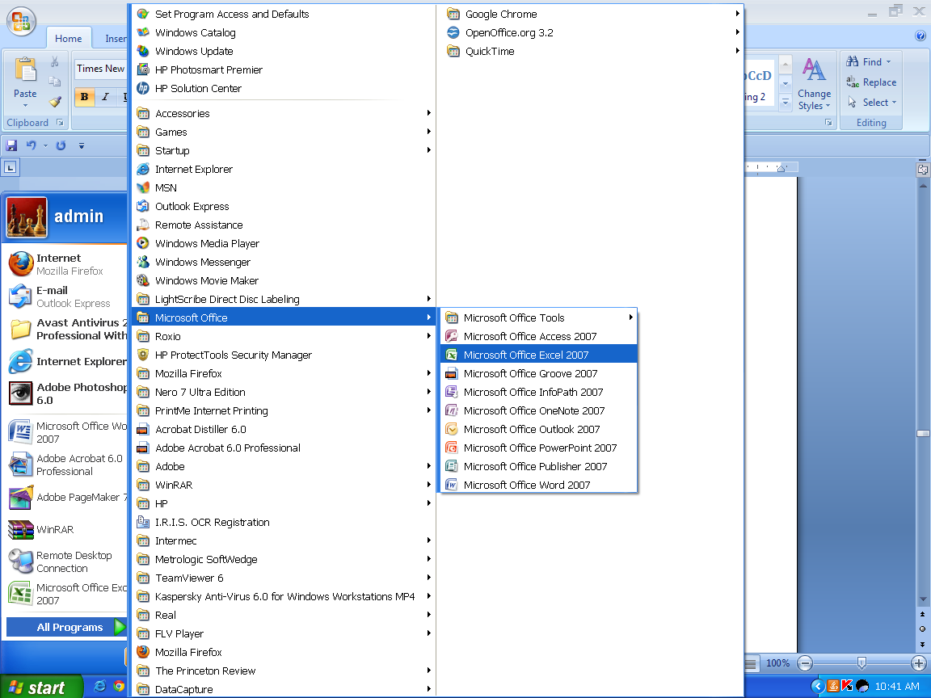

Major operations of MS Excel
1. Create, open, save, edit workbook.
2. Page setup, menu commands, and alignment.
3. Calculation in the worksheet, entering & editing a formula.
4. Working with Charts (Line chart, Bar chart, Pie chart etc.).
Example of a Spreadsheet: 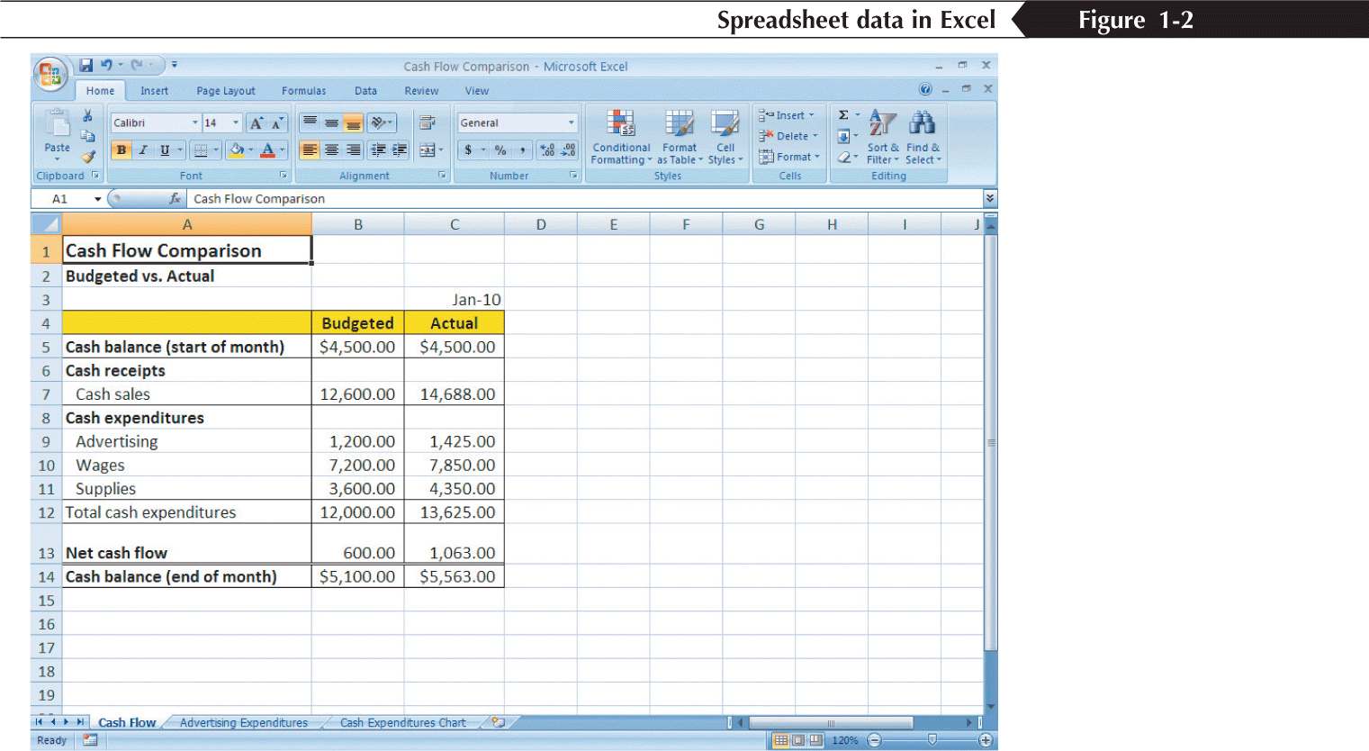

Overview of toolbars:
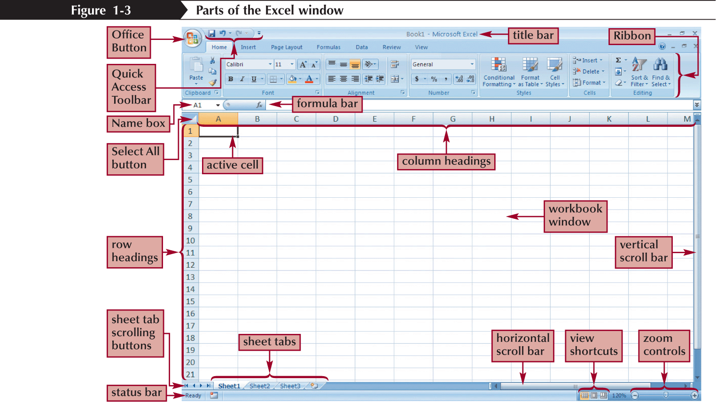
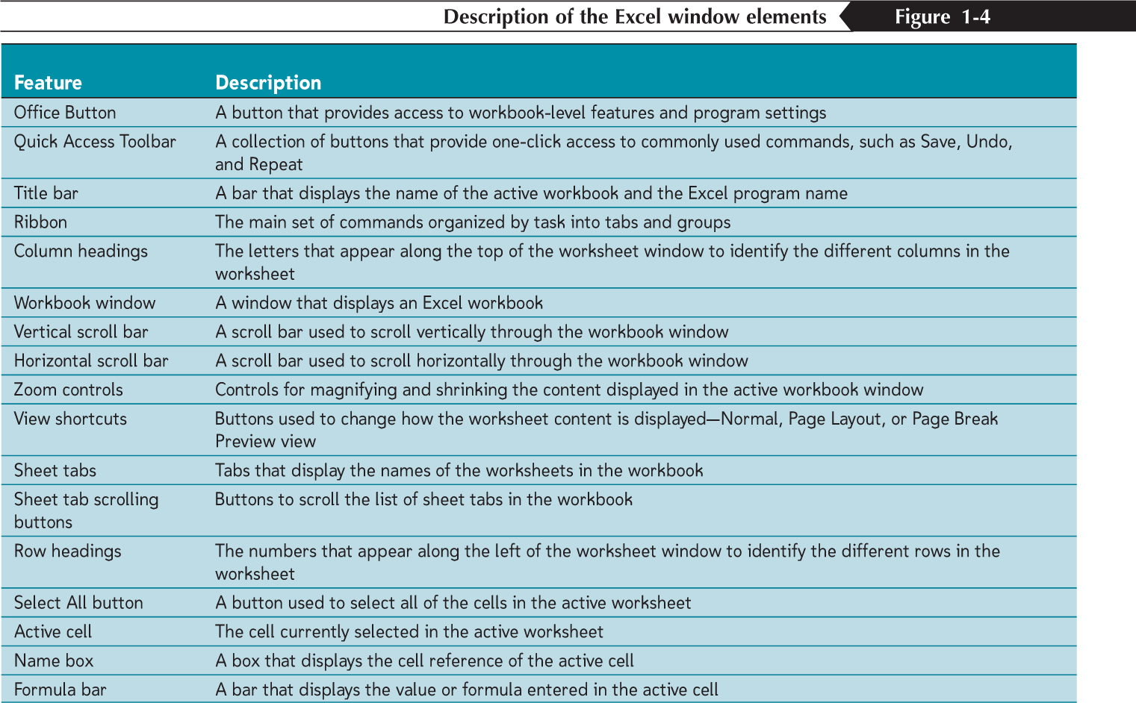
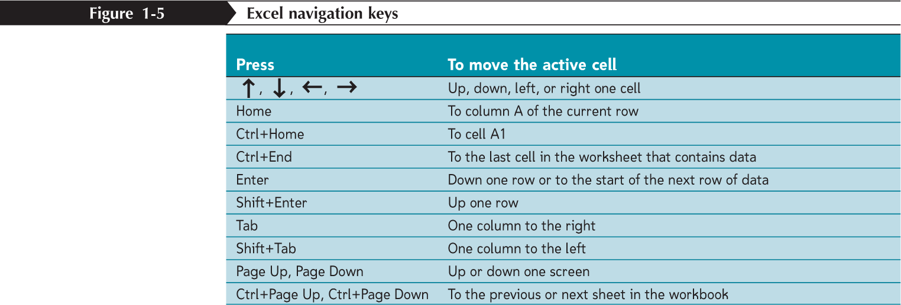
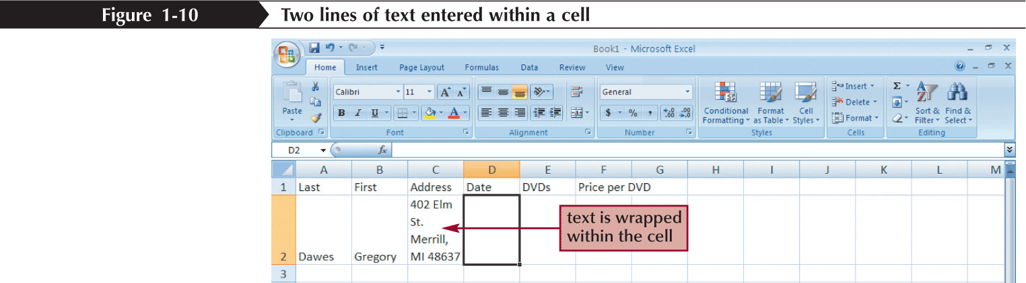
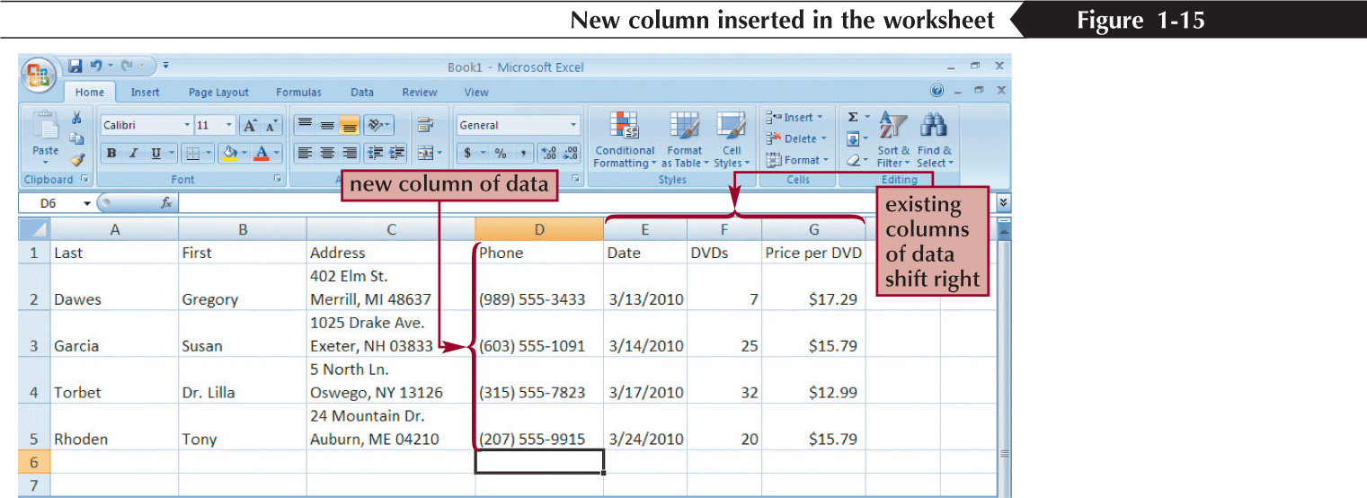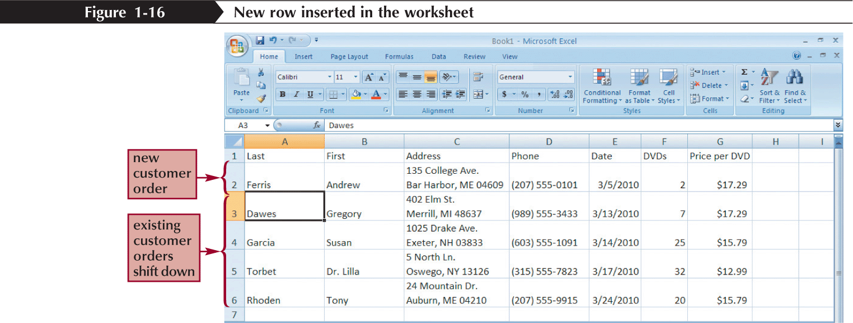
Selecting cell ranges
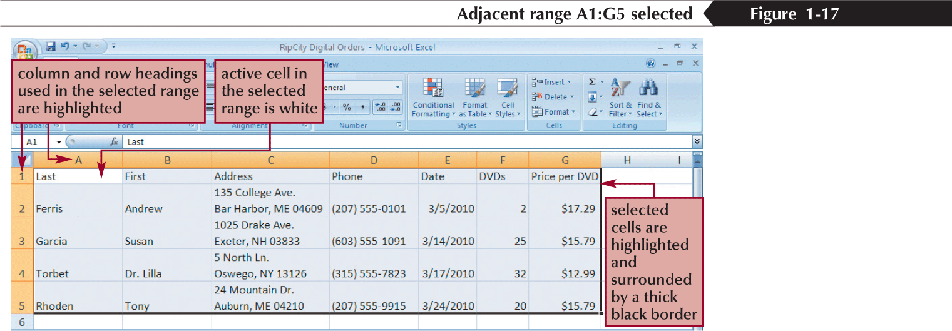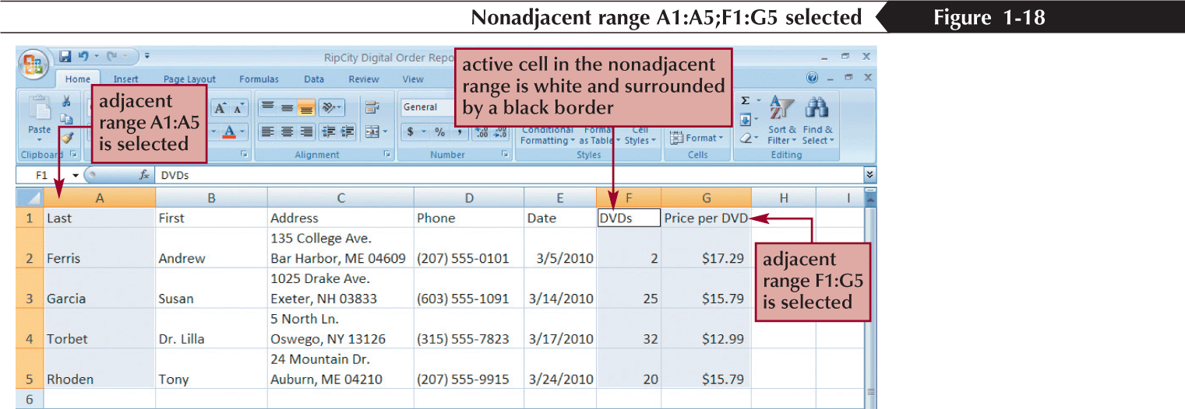

Saving excel files:
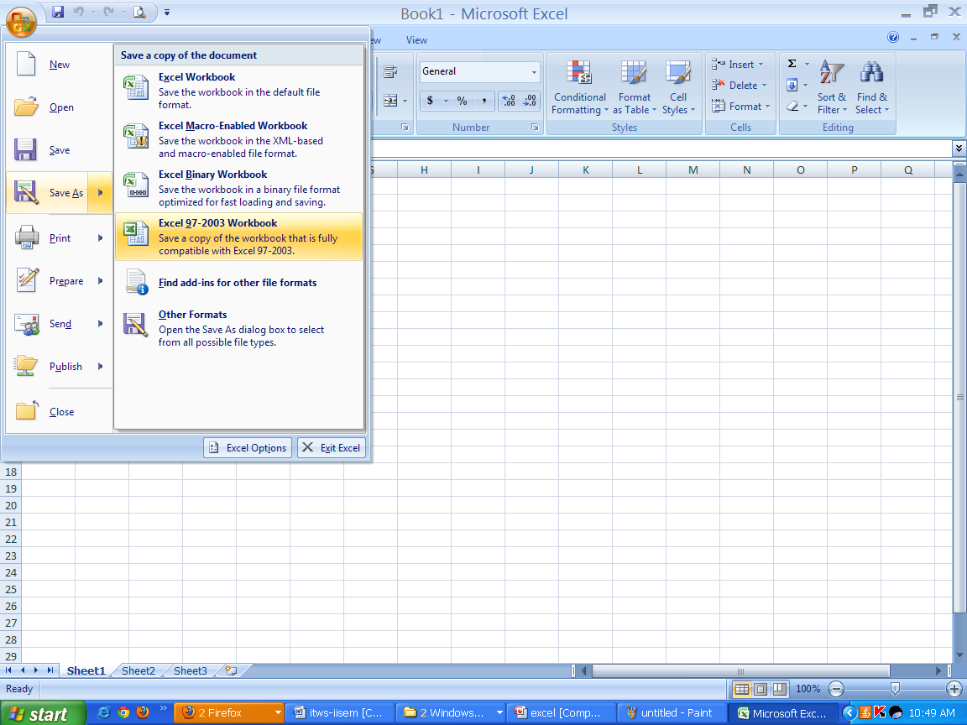
Grid lines:
Gridlines are the faint lines that appear around cells in Excel 2007. They are used to distinguish cells on the worksheet.
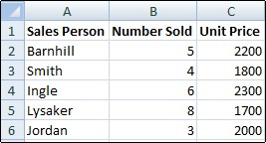
Format cells:
A style in Excel 2007 is a combination of formatting options that is named and saved as part of your current spreadsheet file. The new style can then quickly be applied to data and cells in the spreadsheet.
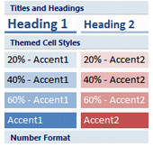
Steps to Create a Custom Formatting Style in Excel 2007
- Select a single spreadsheet cell.
- Apply all desired formatting options to this cell.
- Click the Home tab on the ribbon.
- Click on the Cell Styles option on the ribbon to open the Cell Styles gallery.
- Click on the New cell styles option at the bottom of the gallery to open the Style dialog box.
- Type a name for the new style in the Style name box.
- The formatting options already applied to the selected cell will be listed in the dialog box.

To make additional formatting options or modify the current choices:
- Click on the Format button in the Style dialog box to open the Format Cells dialog box.
- Click on the appropriate tab in the dialog box.
- Make the desired changes.
- Click OK to close the Format Cells dialog box.
- Click OK to close the Style dialog box.
- The new style is added to the top of the Cell Styles gallery
To apply the new style to cells in your spreadsheet
- Select the desired cells.
- Click the Home tab on the ribbon.
- Click on the Cell Styles option on the ribbon to open the Cell Styles gallery.
- Click on the new style name at the top of the gallery.
- The style's formatting is immediately applied to the selected cells.

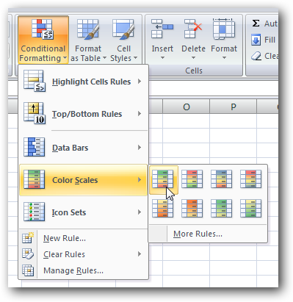

This will automatically color the items based on the range they are in…
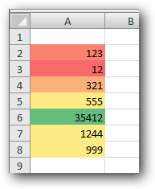

Summation:
Probably the most popular function in any spreadsheet is the SUM function. The Sum function takes all of the values in each of the specified cells and totals their values. The syntax is:
- =SUM(first value, second value, etc)
In the first and second spots you can enter any of the following (constant, cell, range of cells).
- Blank cells will return a value of zero to be added to the total.
- Text cells can not be added to a number and will produce an error.

Let's use the table here for the discussion that follows:  We will look at several different specific examples that show how the typical function can be used! Notice that in A4 there is a TEXT entry. This has NO numeric value and can not be included in a total.
   | A
  1 | 25
  2 | 50
  3 | 75
  4 | test
  5

Example | Cells to ADD | Answer
=sum(A1:A3) | A1, A2, A3 | 150
=sum(A1:A3, 100) | A1, A2, A3 and 100 | 250
=sum(A1+A4) | A1, A4 | #VALUE!
=sum(A1:A2, A5) | A1, A2, A5 | 75

Auto fill:
When you fill in data based on adjacent cells by dragging the fill handle in Microsoft Excel, the Auto Fill Options button is displayed just below and to the right of your filled selection. When you click the Auto Fill Options button, a list of options appears that allows you to choose to fill the cells with text or data, and whether or not to include the format of the initial selection or to copy only the format.
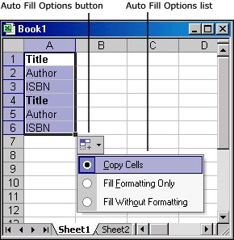
The Auto Fill Options button is also displayed after you select the AutoFill option in the Series dialog box. To show the Series dialog box, use one of the following procedures, as appropriate for the version of Excel that you are running:
- In Microsoft Office Excel 2007 and Excel 2010, click the Home tab, and then click Fill in the Editing group.
- In Microsoft Office Excel and in earlier versions of Excel, point to Fill on the Edit menu, and then click Series.
The options that are available depend on the type of content in the cells (text or numbers) and on the format of the data. You can use the Series command to find the AutoFill option and other options.
Fill down:
Often we have several cells that need the same formula (in relationship) to the location it is to be typed into. There is a short cut that is called Fill Down. There are a number of ways to perform this operation. One of the ways is to
- select the cell that has the original formula
- hold the shift key down and click on the last cell (in the series that needs the formula)
- under the edit menu go down to fill and over to down
 | Cells information is copied from its relative position. In other words in the original cell (C1) the equation was (A1+B1). When we paste the function it will look to the two cells to the left. So the equation pasted into (C2) would be (A2+B2). And the equation pasted into (C3) would be (A3+B3). And the equation pasted into (C4) would be(A4+B4).
   | A | B | C
  1 | 5 | 3 | =A1+B1
  2 | 8 | 2 | fill down
  3 | 4 | 6 | fill down
  4 | 3 | 8 | fill down
Fill right:
We can also fill right. We must select the original cell (and the cells to the right) and select from the Edit menu -- Fill and Right.
 | If we were to fill right from A1 to C1 we would get the formulas displayed to the left. Notice that the second part of the equation is FIXED or (ABSOLUTE REFERENCE so always references B3 which is 10).
   | A | B | C
  1 | =A2+$B$3 | =B2+$B$3 | =C2+$B$3
  2 | 6 | 2 | 5
  3 | 7 | 10 | 4
  4 | 9 | 8 | 7
Answers would be A1=16, B1=12, C1=15.
Formatting text:
We can use most of the tricks in our word processor to do the formatting of text. We can use : bold face, italics, underline, change the color, align (left, right, center), font size, font, etc.
We need to select the cell (or group of cells) that we wish to change the formatting and then go from the FORMAT menu -- down to CELLS -- click on FONT. Here is a picture of what you will see there. Notice that you can choose to change the alignment as well as several other options.
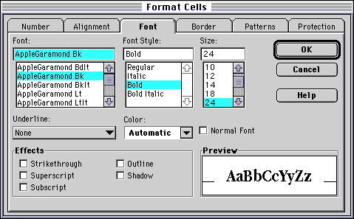

Formula in excel:

Excel Formulas
A formula is nothing more than an equation that you write up. In Excel a typical formula might contain cells, constants, and even functions. Here is an example Excel formula that we have labeled for your understanding.
Advertise on Tizag.com
=B3 * 5 / SUM(B4:B7)
- cell(s): B3 and the range of cells from B4:B7
- constant(s): 5
- function(s): SUM()
There are many functions built into many spreadsheets. One of the first ones that we are going to discuss is the Average function. The average function finds the average of the specified data. (Simplifies adding all of the indicated cells together and dividing by the total number of cells.) The syntax is as follows.
- =Average (first value, second value, etc.)
Text fields and blank entries are not included in the calculations of the Average Function.

Let's use the table here for the discussion that follows:  We will look at several different specific examples that show how the average function can be used!
   | A
  1 | 25
  2 | 50
  3 | 75
  4 | 100
  5

Example | Cells to average | Answer
=average (A1:A4) | A1, A2, A3, A4 | 62.5
=average (A1:A4, 300) | A1, A2, A3, A4 and 300 | 110
=average (A1:A5) | A1, A2, A3, A4, A5 | 62.5
=average (A1:A2, A4) | A1, A2, A4 | 58.33

Excel Formulas: Creating Your First Formula
This first formula will be as simple as they come and will teach you the basic form of an Excel formula. Create a new spreadsheet and then follow these steps:
- Select cell A1
- Type the following basic arithmetic formula into cell A1: =1+1
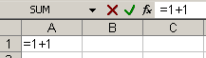
- Press Enter and notice how cell A1 changes from your formula to the result!
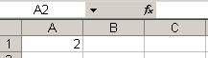
This may seem simple, but there are a some very important things you should get out of this example. When you start off a cell entry with the equal sign "=" you are telling Excel that you want it to evaluate the following formula.
In our case we had a simple "1+1" we wanted Excel to solve for us. You can do this for addition, subtraction, multiplication, division and any other operation you can think of.
Remember, if you do not start your entry with the equal sign, then Excel will not evaluate the cell!

Using Cells to Create Dynamic Formulas
The most powerful aspect of Excel is not the simple calculator abilities we describes in our first formula example, but rather the ability to take values from cells to be used in your formulas.
Let's set up a basic sales spreadsheet to help explain this topic.
- In cells A1-D4 enter the following information:
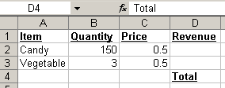
Notice: that cell D2 and D3 are blank, but should contain the amount of money from selling 150 candy items and 3 vegetables. By referencing the Quantity and Price cells we will be able to do this! Let's begin with Candy.
- Note:It is very important to follow these steps exactly without interruptions! Select cell D2, candy's "revenue", and type the equal sign "=" to begin your formula.
- Left-click on cell B2, Candy's Quantity and notice your formula is now "=B2"
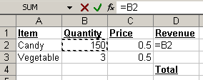
- We want to multiply Quanity(B2) by Price(B3) so enter an asterisk (*)
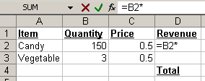
- Now left-click on Candy's Price (C2)to complete your formula!
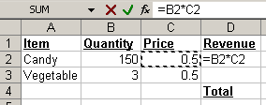
- If your formula looks like ours then press Enter, otherwise you can manually enter the formula "=B2*C2". However, we really think it is easier and preferred to click on cells to reference them, instead of entering that information manually.
- After you pressed Enter your Candy Revenue cell should be functioning properly and contain the value 75.
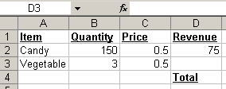
- Using your newly gained knowledge please complete Vegetable's Revenue by repeating steps 2-7 for Vegetable
- Your spreadsheet should now look like this:
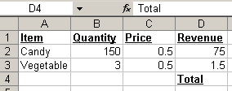
- Cheatsheet: If you are having trouble creating the formula for Vegetable's Revenue it is "=B3*C3"

Advanced Excel Formulas: Using Formulas in Formulas
Now that we have created separate revenues for both Candy and Vegetable it would be nice to somehow combine these two values to get the Total Revenue. Although both Vegetable Revenue and Candy Revenue contain formulas, we can still use these cells as we have been doing and add them together to get our total.
- Select cell D5 (directly below "Total")
- Type the equal sign "="
- Left-click cell D2
- Type the plus sign "+"
- Left-click cell D3. Cell D5 should now contain this formula "=D2+D3":
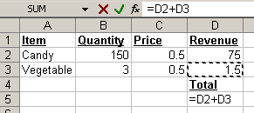
- Press Enter to complete your Total Revenue!
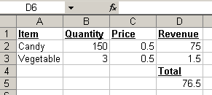

Creating a chart:

Creating Charts
In Microsoft Excel, you can represent numbers in a chart. On the Insert tab, you can choose from a variety of chart types, including column, line, pie, bar, area, and scatter. The basic procedure for creating a chart is the same no matter what type of chart you choose. As you change your data, your chart will automatically update.
You select a chart type by choosing an option from the Insert tab's Chart group. After you choose a chart type, such as column, line, or bar, you choose a chart sub-type. For example, after you choose Column Chart, you can choose to have your chart represented as a two-dimensional chart, a three-dimensional chart, a cylinder chart, a cone chart, or a pyramid chart. There are further sub-types within each of these categories. As you roll your mouse pointer over each option, Excel supplies a brief description of each chart sub

Create a Chart
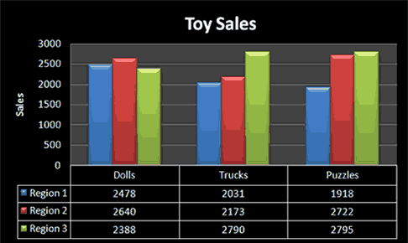

To create the column chart shown above, start by creating the worksheet below exactly as shown.
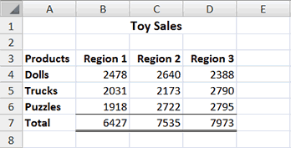
After you have created the worksheet, you are ready to create your chart.

Create a Column Chart

.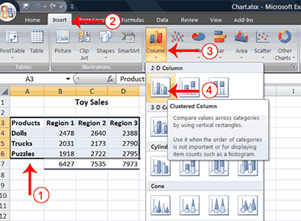
- Select cells A3 to D6. You must select all the cells containing the data you want in your chart. You should also include the data labels.
- Choose the Insert tab.
- Click the Column button in the Charts group. A list of column chart sub-types types appears.
- Click the Clustered Column chart sub-type. Excel creates a Clustered Column chart and the Chart Tools context tabs appear.

Apply a Chart Layout
Context tabs are tabs that only appear when you need them. Called Chart Tools, there are three chart context tabs: Design, Layout, and Format. The tabs become available when you create a new chart or when you click on a chart. You can use these tabs to customize your chart.
You can determine what your chart displays by choosing a layout. For example, the layout you choose determines whether your chart displays a title, where the title displays, whether your chart has a legend, where the legend displays, whether the chart has axis labels and so on. Excel provides several layouts from which you can choose.

Apply a Chart Layout
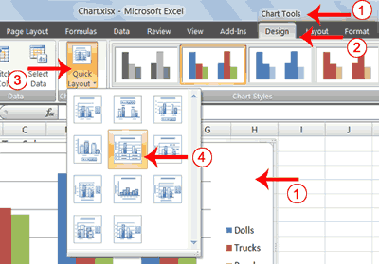
- Click your chart. The Chart Tools become available.
- Choose the Design tab.
- Click the Quick Layout button in the Chart Layout group. A list of chart layouts appears.
- Click Layout 5. Excel applies the layout to your chart.

Add Labels
When you apply a layout, Excel may create areas where you can insert labels. You use labels to give your chart a title or to label your axes. When you applied layout 5, Excel created label areas for a title and for the vertical axis.

Add labels
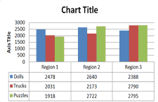 | 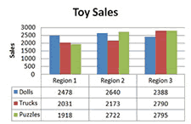
Before | After
- Select Chart Title. Click on Chart Title and then place your cursor before the C in Chart and hold down the Shift key while you use the right arrow key to highlight the words Chart Title.
- Type Toy Sales. Excel adds your title.
- Select Axis Title. Click on Axis Title. Place your cursor before the A in Axis. Hold down the Shift key while you use the right arrow key to highlight the words Axis Title.
- Type Sales. Excel labels the axis.
- Click anywhere on the chart to end your entry.

Switch Data
If you want to change what displays in your chart, you can switch from row data to column data and vice versa.

Switch Data
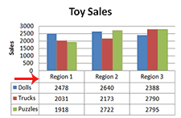 | 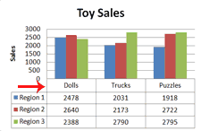
Before | After
- Click your chart. The Chart Tools become available.
- Choose the Design tab.
- Click the Switch Row/Column button in the Data group. Excel changes the data in your chart.

Change the Style of a Chart
A style is a set of formatting options. You can use a style to change the color and format of your chart. Excel 2007 has several predefined styles that you can use. They are numbered from left to right, starting with 1, which is located in the upper-left corner.

Change the Style of a Chart
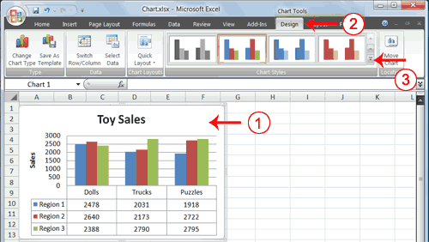
- Click your chart. The Chart Tools become available.
- Choose the Design tab.
- Click the More buttons in the Chart Styles group. The chart styles appear.
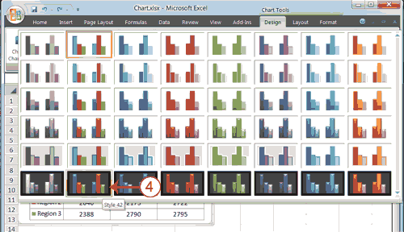
- Click Style 42. Excel applies the style to your chart.

Change the Size and Position of a Chart
When you click a chart, handles appear on the right and left sides, the top and bottom, and the corners of the chart. You can drag the handles on the top and bottom of the chart to increase or decrease the height of the chart. You can drag the handles on the left and right sides to increase or decrease the width of the chart. You can drag the handles on the corners to increase or decrease the size of the chart proportionally. You can change the position of a chart by clicking on an unused area of the chart and dragging.Change the Size and Position of a Chart
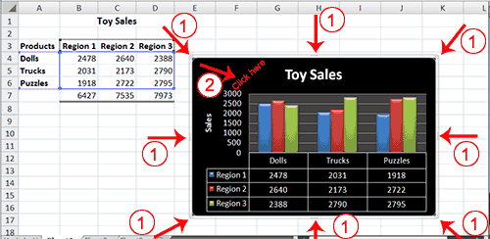
- Use the handles to adjust the size of your chart.
- Click an unused portion of the chart and drag to position the chart beside the data.

Move a Chart to a Chart Sheet
By default, when you create a chart, Excel embeds the chart in the active worksheet. However, you can move a chart to another worksheet or to a chart sheet. A chart sheet is a sheet dedicated to a particular chart. By default Excel names each chart sheet sequentially, starting with Chart1. You can change the name.

Move a Chart to a Chart Sheet
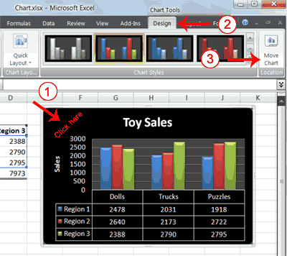
- Click your chart. The Chart Tools become available.
- Choose the Design tab.
- Click the Move Chart button in the Location group. The Move Chart dialog box appears.
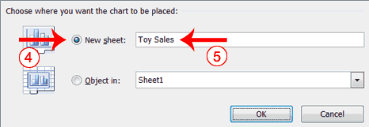
- Click the New Sheet radio button.
- Type Toy Sales to name the chart sheet. Excel creates a chart sheet named Toy Sales and places your chart on it.

Change the Chart Type
Any change you can make to a chart that is embedded in a worksheet, you can also make to a chart sheet. For example, you can change the chart type from a column chart to a bar chart.

Change the Chart Type
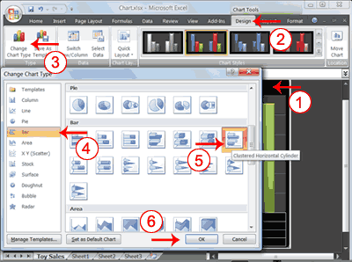
- Click your chart. The Chart Tools become available.
- Choose the Design tab.
- Click Change Chart Type in the Type group. The Chart Type dialog box appears.
- Click Bar.
- Click Clustered Horizontal Cylinder.
- Click OK. Excel changes your chart type.
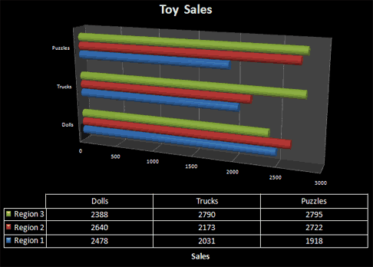
Hyper linking:
In Excel, the Hyperlink function creates a shortcut to a file or Internet address.
The syntax for the Hyperlink function is:
Hyperlink ( link, display_name )
link is a path to the file or the URL to the Internet address.
display_name is optional. It is the value that appears in the cell. If this parameter is omitted, then the link will appear in the cell.
For example:
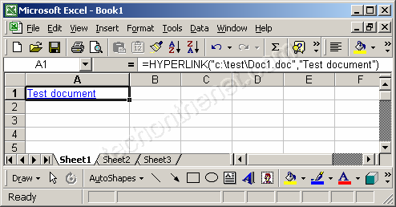
In our first example, we're using the Hyperlink function to reference a file called "Doc1.doc" that can be found in the c:\test\ directory. The following formula has been entered in cell A1:
=Hyperlink("c:\test\Doc1.doc","Test document")
When a user clicks on cell A1, the Word document called "Doc1.doc" will automatically open.

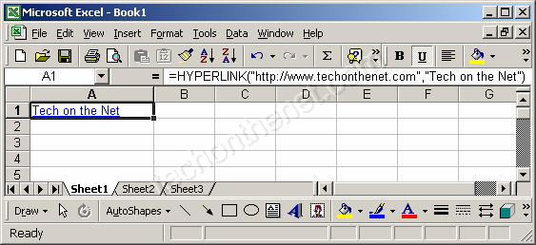
In our second example, we're using the Hyperlink function to reference an Internet address. The following formula has been entered in cell A1:
=Hyperlink("http://www.techonthenet.com","Tech on the Net")
When a user clicks on cell A1, the default web browser will open to the site called www.techonthenet.com.

Count function:
Excel's COUNT function is one of a group of Count Functions that can be used when you need to total the number of cells in a selected range.
The COUNT function's job is to only add up the cells in a selected range that contain numbers. It ignores empty cells or those contain text. If a number is later added to an empty cell the function will be automatically updated to include this new data.
Be aware that dates, times, functions, and formulas are stored as numbers in Excel. The COUNT function will, therefore, include any cells containing these types of data in the total.
The syntax for the COUNT function is:
=COUNT( Range )
Range - the group of cells the function is to count.
Example Using Excel 2007's COUNT Function:
Note: For help with this example, see the image above.
- Enter the following data into cells D1 to D4: 11, twelve, 13, 14.
- Enter the following data into cell D6: 16.
- Note that we have intentionally left cell D5 blank.
- Click on cell E1 - the location where the results will be displayed.
- Click on the Formulas tab.
- Choose More Functions > Statistical from the ribbon to open the function drop down list.
- Click on COUNT in the list to bring up that function's dialog box.
- Drag select cells D1 to D6 on the spreadsheet to enter the range into the dialog box.
- Click OK.
- The answer 4 should appear in cell E1 since only four of the six cells in the range contain numbers.
- Cell D2, which contains text, and cell D5, which is blank, are ignored by the COUNT function.
- When you click on cell E1 the complete function =COUNT( D1 : D6 ) appears in the formula bar above the worksheet.
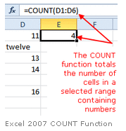
Lookup/Vlookup :
Lookup:
The Lookup Value
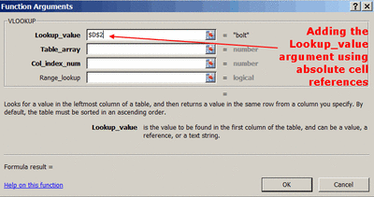
The lookup value is located in the first column of the table of data. After specifying a subject in the first column, VLOOKUP will then allow you to search for specific information located in the same row as the subject.
The lookup value can be a text string, a logical value (TRUE or FALSE only), a number, or a cell reference to a value.
It is a good idea to use an absolute cell reference for the lookup value.
If you don’t use an absolute reference and you copy the VLOOKUP function to other cells, there is a good chance you will get error messages in the cells the function is copied to.
Vlookup:
Excel VLOOKUP Function
Excel's VLOOKUP function, which stands for vertical lookup, can help you find specific information in large data tables such as an inventory list of parts or a large membership contact list.
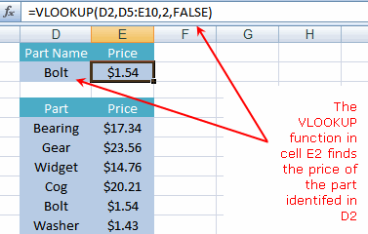

Sorting:
Excel's sort feature is a quick and easy way to sort data in a spreadsheet. The options for sorting your data include:
- Sort in ascending order - A to Z alphabetically or smallest to largest for number data.
- Sort in descending order - Z to A alphabetically or largest to smallest for number data.
- Custom sort - includes sorting by the cell background color or the font color of the data.

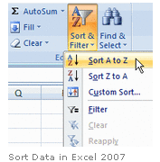

Example: Sort Data in Excel
For help with this example, see the image above.
- Enter the following data into cells A1 to A6: 40, 20, 30, 60, 5, 25.

- Drag select cells A1 to A6 to highlight them.

- Click on the Home tab of the ribbon.

- Click on the Sort & Filter icon on the ribbon to open the drop down list.

- Click on Sort smallest to largest.

- The data in cells A1 to A6 should now be in this order:
5, 20, 25, 30, 40, 60.
Note: Excel knows the difference between text and number data and adjust the options in the drop down list accordingly. For example, if cells A1 to A6 contained text - such as words or letters of the alphabet - instead of numbers the options in the Sort & Filter drop down list would change to Sort A to Z instead of Sort smallest to largest .
Also Note: If you have multiple columns of related data and you wish to perform a simple sort on one of those columns - such as sorting an address list by the person's last name - remember to select all columns of related data before carrying out the sort in order to keep your data together.
Conditional formatting:
You can also create your own rule to color only cells that fit within a certain range, or greater than a certain number.
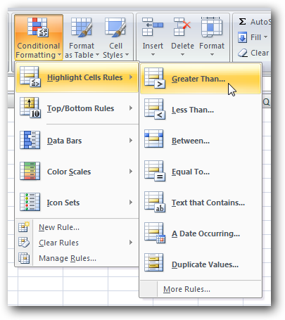
This rule will only color cells greater than a certain amount, with the color you specify.
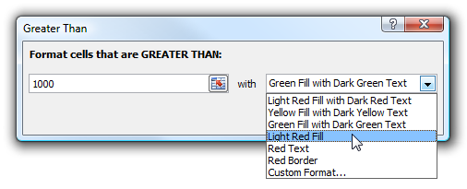
This can be very useful, and you should note that you can apply a second rule to the same range. For instance, I added a second rule that colored items larger than 2000 with green instead of red.
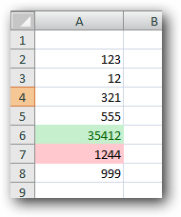

Python Programming Lab
Week -1:
- Use a web browser to go to the Python website http://python.org. This page contains information about Python and links to Python-related pages, and it gives you the ability to search the Python documentation.
- Start the Python interpreter and type help() to start the online help utility.
- Start Python interpreter and use it as Calculator.

Week -2:
- If you run a 10 kilometer race in 43 minutes 30 seconds, what is your average time per mile? What is your average speed in miles per hour? (Hint: there are 1.61 kilometers in a mile).
- The volume of a sphere with radius r is 5? (Use Sphere volume formula)

- Suppose the cover price of a book is $24.95, but bookstores get a 40% discount.
Shipping costs $3 for the first copy and 75 cents for each additional copy. What is
the total wholesale cost for 60 copies?

Week -3:
- A function object is a value you can assign to a variable or pass as an argument. For
example, do_twice is a function that takes a function object as an argument and calls it
twice:
def do_twice(f):
f()
f()
Here’s an example that uses do_twice to call a function named print_spam twice.
def print_spam():
print 'spam'
do_twice(print_spam)
a. Type this example into a script and test it.
b. Modify do_twice so that it takes two arguments, a function object and a value, and
calls the function twice, passing the value as an argument.
c. Write a more general version of print_spam, called print_twice, that takes a string
as a parameter and prints it twice.
d. Use the modified version of do_twice to call print_twice twice, passing 'spam' as
an argument.
- Write a function that draws a grid like the following:
+ - - - - + - - - - +
| | |
| | |
| | |
+ - - - - + - - - - +
| | |
| | |
| | |
| | |
+ - - - - + - - - - +
Hint: to print more than one value on a line, you can print a comma-separated
sequence.
9. Write a function called gcd that takes parameters a and b and returns their
greatest common divisor.
10. Write a function called is_palindrome that takes a string argument and returns
True if it is a palindrome and False otherwise. Remember that you can use the
built-in function len to check the length of a string.

Week-4:
11. Write a function called is_sorted that takes a list as a parameter and returns True if the
list is sorted in ascending order and False otherwise.
12. Write a function called has_duplicates that takes a list and returns True if there is any
element that appears more than once. It should not modify the original list.
- Write a function called remove_duplicates that takes a list and returns a new list with
only the unique elements from the original. Hint: they don’t have to be in the same
order.
- The wordlist I provided, words.txt, doesn’t contain single letter words. So you might
want to add “I”, “a”, and the empty string.
- Write a python code to read a dictionary values from the user. Construct a function to
invert its content. i.e., keys should be values and values should be keys.

Week-5:
- If there are 23 students in your class, what are the chances that two of you have the same birthday? You can estimate this probability by generating random samples of 23 birthdays and checking for matches.
Hint: you can generate random birthdays with the randint function in the random module.
- How does a module source code file become a module object?
- Why might you have to set your PYTHONPATH environment variable?
- What is a namespace, and what does a module’s namespace contain?
- How do you make a module? Give an example of construction of a module using different geometrical shapes and operations on them as its functions.
- What is the purpose of a _ _init_ _.py file in a module package directory? Explain with a suitable example.
- Use the structure of exception handling all general purpose exceptions.

Week-6:
- a. Write a function called draw_rectangle that takes a Canvas and a Rectangle as
arguments and draws a representation of the Rectangle on the Canvas.

b. Add an attribute named color to your Rectangle objects and modify draw_rectangle
so that it uses the color attribute as the fill color.

c. Write a function called draw_point that takes a Canvas and a Point as arguments and
draws a representation of the Point on the Canvas.

d. Define a new class called Circle with appropriate attributes and instantiate a few
Circle objects. Write a function called draw_circle that draws circles on the canvas.

- Write a Python program to demonstrate the usage of MRO in multiple levels of
Inheritances.
- Write a python code to read a phone number and email-id from the user and validate it for correctness.

Week-7:
- Write a Python code to merge two given file contents into third file.
- Write a Python code to open a given file and construct a function to check for given words present in it and display on found.

Week-8:
- Import numpy, Plotpy and Scipy and explore their functionalities.
- Write a GUI program to create a window wizard having two text labels, two text fields and two buttons as Submit and Reset.

Python Programming Lab
Week -1:
  - Use a web browser to go to the Python website
This page contains information about Python and links to Python-related pages, and it gives you the ability to search the Python documentation.

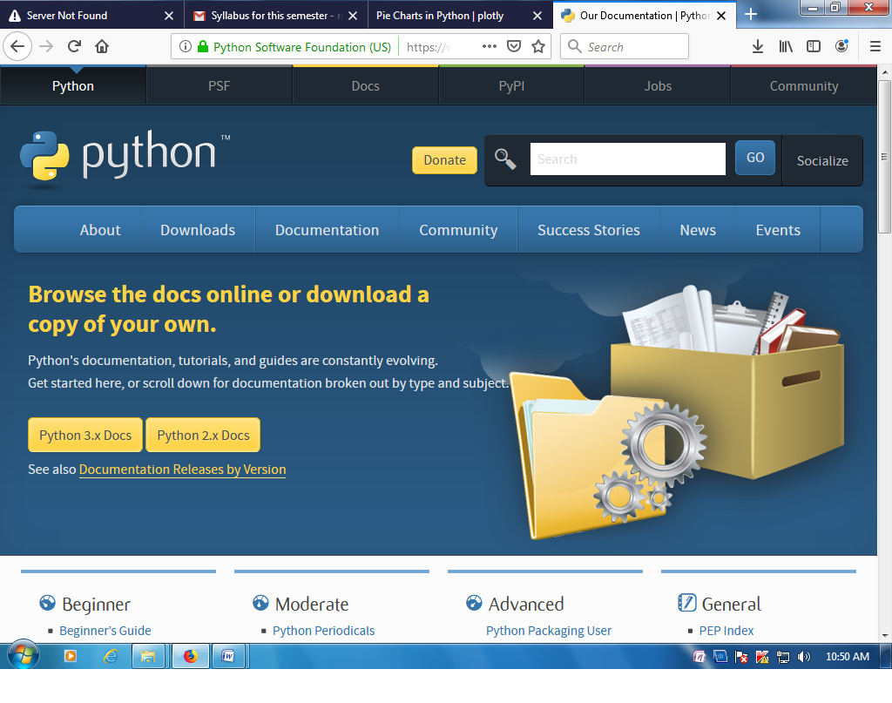

2.Start the Python interpreter and type help() to start the online help utility.

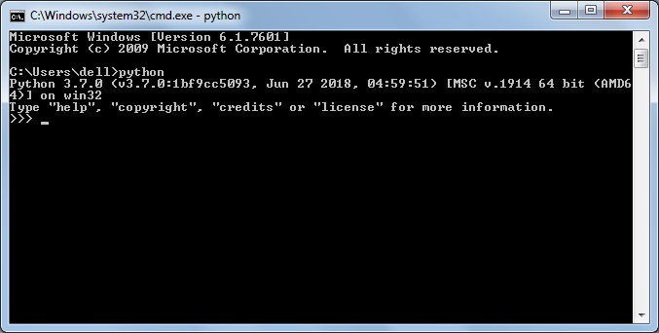

3.Start Python interpreter and use it as Calculator. 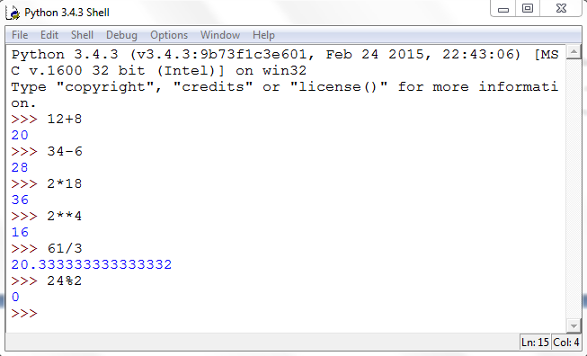
Week -2:
- The volume of a sphere with radius r is 5? (Use Sphere volume formula)

pi = 3.1415926535897931
2r= 6.0
V= 4.0/3.0*pi* r**3
print('The volume of the sphere is: ',V)
line that has just executed

- Suppose the cover price of a book is $24.95, but bookstores get a 40% discount.
Shipping costs $3 for the first copy and 75 cents for each additional copy. What is the
total wholesale cost for 60 copies?
- If you run a 10 kilometer race in 43 minutes 30 seconds, what is your average time per mile? What is your average speed in miles per hour? (Hint: there are 1.61 kilometers in a mile).

Week -3:
- A function object is a value you can assign to a variable or pass as an argument. For
example, do_twice is a function that takes a function object as an argument and calls it
twice:
def do_twice(f):
f()
f()
Here’s an example that uses do_twice to call a function named print_spam twice.
def print_spam():
print 'spam'
do_twice(print_spam)
a. Type this example into a script and test it.

b. Modify do_twice so that it takes two arguments, a function object and a value, and
calls the function twice, passing the value as an argument.

c. Write a more general version of print_spam, called print_twice, that takes a string
as a parameter and prints it twice.

d. Use the modified version of do_twice to call print_twice twice, passing 'spam' as
an argument.

- Write a function that draws a grid like the following:

+ - - - - + - - - - +
| | |
| | |
| | |
+ - - - - + - - - - +
| | |
| | |
| | |
| | |
+ - - - - + - - - - +

Hint: to print more than one value on a line, you can print a comma-separated
sequence.

- . Write a function called gcd that takes parameters a and b and returns their
greatest common divisor.
- . Write a function called is_palindrome that takes a string argument and returns
True if it is a palindrome and False otherwise. Remember that you can use the
built-in function len to check the length of a string.

Week-4:
- . Write a function called is_sorted that takes a list as a parameter and returns True if the list is sorted in ascending order and False otherwise.
def is_sorted(vlist):
n=len(vlist)
i=1
flag=0
while i<n:
if (vlist[i]>vlist[i-1]):
flag+=1
else:
break
i+=1
if flag==n-1:
return 'true'
else:
return 'false'
input_string=input("Enter the list elements:")
vlist= input_string.split()
print(is_sorted(vlist))

- Write a function called has_duplicates that takes a list and returns True if there is any
element that appears more than once. It should not modify the original list.
def has_duplicates(vlist):
n=len(vlist)
rep=[]
for i in range(n):
k=i+1
for j in range(k,n):
if vlist[i]==vlist[j]:
return 'true'
return 'false'
input_string=input("Enter the list elements:")
vlist= input_string.split()
print(has_duplicates(vlist))

- Write a function called remove_duplicates that takes a list and returns a new list with
only the unique elements from the original. Hint: they don’t have to be in the same
order.
def remove_duplicates(vlist):
final_list = []
for num in vlist:
if num not in final_list:
final_list.append(num)
return final_list
input_string=input("Enter the list elements:")
vlist= input_string.split()
print(remove_duplicates(vlist))

- Write a python code to read a dictionary values from the user. Construct a function to invert its content. i.e., keys should be values and values should be keys.

def invert_dict(d):
return dict([(v, k) for k, v in d.items()])
user_input = input("Enter key and value separated by commas (,): ")
key, value = user_input.split(",")
d=dict()
d[key]=value
print(invert_dict(d))

- The wordlist I provided, words.txt, doesn’t contain single letter words. So you might want to add “I”, “a”, and the empty string.

Week-5:
- If there are 23 students in your class, what are the chances that two of you have the same birthday? You can estimate this probability by generating random samples of 23 birthdays and checking for matches.
Hint: you can generate random birthdays with the randint function in the random module.
import random
classSize = 23
numTrials = 1000
dupeCount = 0

for trial in range(numTrials):
birthdayList = []
for i in range(classSize):
newBDay = random.randint(1,365)
birthdayList.append(newBDay)

foundDupe = False
for num in birthdayList:
if birthdayList.count(num) > 1:
foundDupe = True

if foundDupe == True:
dupeCount = dupeCount + 1

prob = dupeCount / numTrials
print("The probability of a shared birthday in a class of ", classSize, " is ", prob)

- How do you make a module? Give an example of construction of a module using different geometrical shapes and operations on them as its functions.
from turtle import *
canvas = Screen()
canvas.setup(400,400)
def square():
sarah = Turtle()
sarah.forward(50)
sarah.left(90)
sarah.forward(50)
sarah.left(90)
sarah.forward(50)
sarah.left(90)
sarah.forward(50)
sarah.left(90)
canvas.exitonclick()
def rectangle():
sarah = Turtle()
sarah.forward(50)
sarah.left(90)
sarah.forward(20)
sarah.left(90)
sarah.forward(50)
sarah.left(90)
sarah.forward(20)
sarah.left(90)
canvas.exitonclick()
def hexagon():
sarah = Turtle()
sarah.forward(50)
sarah.left(60)
sarah.forward(50)
sarah.left(60)
sarah.forward(50)
sarah.left(60)
sarah.forward(50)
sarah.left(60)
sarah.forward(50)
sarah.left(60)
sarah.forward(50)

- What is the purpose of a _ _init_ _.py file in a module package directory? Explain with a suitable example.

class Rectangle:
def __init__(self, length, breadth, unit_cost=0):
self.length = length
self.breadth = breadth
self.unit_cost = unit_cost
def get_area(self):
return self.length * self.breadth
def calculate_cost(self):
area = self.get_area()
return area * self.unit_cost
r = Rectangle(160, 120, 2000)
print("Area of Rectangle: %s sq units" % (r.get_area()))

- Use the structure of exception handling all general purpose exceptions.

try:
fh = open("testfile", "w")
try:
fh.write("This is my test file for exception handling!!")
finally:
print("Going to close the file")
fh.close()
except IOError:
print("Error: can\'t find file or read data")

- How does a module source code file become a module object?

- Why might you have to set your PYTHONPATH environment variable?

- What is a namespace, and what does a module’s namespace contain?

Week-6:

22.a. Write a function called draw_rectangle that takes a Canvas and a Rectangle as
arguments and draws a representation of the Rectangle on the Canvas.

from swampy.TurtleWorld import *

class Point(object):
"represents a point in 2-D space"

p = Point()
p.x = 60
p.y = 15

class Rectangle(object):
"""Represents a rectangle."""

box = Rectangle()
box.color = 'blue'
box.bbox = [[-100, -60],[100, 60]]

class Canvas(object):
"""Represents a canvas.
attributes: width, height, background color"""
a_canvas = Canvas()
a_canvas.width = 500
a_canvas.height = 500

def draw_rectangle(canvas, rectangle):
drawn_canvas = world.ca(canvas.width, canvas.height)
drawn_canvas.rectangle(rectangle.bbox, fill=rectangle.color)

world = World()
draw_czech_republic_flag(a_canvas)
world.mainloop()

  - Write a function called draw_point that takes a Canvas and a Point as arguments and draws a representation of the Point on the Canvas.

from swampy.TurtleWorld import *

class Point(object):
"represents a point in 2-D space"

p = Point()
p.x = 60
p.y = 15

class Canvas(object):
"""Represents a canvas.
attributes: width, height, background color"""
a_canvas = Canvas()
a_canvas.width = 500
a_canvas.height = 500

def draw_point(canvas, point):
bbox = [[point.x, point.y], [point.x, point.y]]
drawn_canvas = world.ca(canvas.width, canvas.height)
drawn_canvas.rectangle(bbox, fill="black")

world = World()
draw_czech_republic_flag(a_canvas)
world.mainloop()

  - . Define a new class called Circle with appropriate attributes and instantiate a few
Circle objects. Write a function called draw_circle that draws circles on the canvas.

  - Add an attribute named color to your Rectangle objects and modify draw_rectangle so that it uses the color attribute as the fill color.

23.Write a Python program to demonstrate the usage of MRO in multiple levels of
inheritances.

class Person:
#defining constructor
def __init__(self, personName, personAge):
self.name = personName
self.age = personAge

#defining class methods
def showName(self):
print(self.name)

def showAge(self):
print(self.age)

#end of class definition

# defining another class
class Student: # Person is the
def __init__(self, studentId):
self.studentId = studentId

def getId(self):
return self.studentId

class Resident(Person, Student): # extends both Person and Student class
def __init__(self, name, age, id):
Person.__init__(self, name, age)
Student.__init__(self, id)

# Create an object of the subclass
resident1 = Resident('John', 30, '102')
resident1.showName()
print(resident1.getId())

  - Write a python code to read a phone number and email-id from the user and validate it for correctness.

Week-7:
  - Write a Python code to merge two given file contents into third file.

# Python Program - Merge Two Files

import shutil;
print("Enter 'x' for exit.");
filename1 = input("Enter first file name to merge: ");
if filename1 == 'x':
exit();
else:
filename2 = input("Enter second file name to merge: ");
filename3 = input("Create a new file to merge content of two file inside this file: ");
print();
print("Merging the content of two file in",filename3);
with open(filename3, "wb") as wfd:
for f in [filename1, filename2]:
with open(f, "rb") as fd:
shutil.copyfileobj(fd, wfd, 1024*1024*10);
print("\nContent merged successfully.!");
print("Want to see ? (y/n): ");
check = input();
if check == 'n':
exit();
else:
print();
c = open(filename3, "r");
print(c.read());
c.close();

  - Write a Python code to open a given file and construct a function to check for given words present in it and display on found.

def txt_search_m(self):
files = [f for f in os.listdir(self.path1) if os.path.isfile(self.path1+"/"+f)]
file_number = 0
for file in files:
file_t = open(self.path1+"/"+file)
line_number=1
flag_file = 0
for line1 in file_t:
if self.i:
line1 = line1.lower()
if re.search(self.string2, line1):
flag_file= 1
print "The text "+self.string1+" found in ", file, " at line number ",line_number
line_number=line_number+1
if flag_file == 1:
file_number=file_number+1
flag_file=0
file_t.close()
print "total files are ",file_number

Week-8:
  - Import numpy, Plotpy and Scipy and explore their functionalities.

NumPy - Introduction
NumPy is a Python package. It stands for 'Numerical Python'. It is a library consisting of multidimensional array objects and a collection of routines for processing of array.
Numeric, the ancestor of NumPy, was developed by Jim Hugunin. Another package Numarray was also developed, having some additional functionalities. In 2005, Travis Oliphant created NumPy package by incorporating the features of Numarray into Numeric package. There are many contributors to this open source project.

Operations using NumPy
Using NumPy, a developer can perform the following operations −
- Mathematical and logical operations on arrays.
- Fourier transforms and routines for shape manipulation.
- Operations related to linear algebra. NumPy has in-built functions for linear algebra and random number generation.
- o install NumPy, run the following command.
- Python setup.py install
- To test whether NumPy module is properly installed, try to import it from Python prompt.
- import numpy
- If it is not installed, the following error message will be displayed.
- Traceback (most recent call last):
- File "<pyshell#0>", line 1, in <module>
- import numpy
- ImportError: No module named 'numpy'
Alternatively, NumPy package is imported using the following syntax –

Example 1

import numpy as np
import numpy as np
a = np.array([1,2,3])
print a
The output is as follows −
[1, 2, 3]

Example 2
# more than one dimensions
import numpy as np
a = np.array([[1, 2], [3, 4]])
print a
The output is as follows −
[[1, 2]
[3, 4]]

Example 3
# minimum dimensions
import numpy as np
a = np.array([1, 2, 3,4,5], ndmin = 2)
print a
The output is as follows −
[[1, 2, 3, 4, 5]]

Example 4
# dtype parameter
import numpy as np
a = np.array([1, 2, 3], dtype = complex)
print a
The output is as follows −
[ 1.+0.j, 2.+0.j, 3.+0.j]

SciPy - Introduction

SciPy, a scientific library for Python is an open source, BSD-licensed library for mathematics, science and engineering. The SciPy library depends on NumPy, which provides convenient and fast N-dimensional array manipulation. The main reason for building the SciPy library is that, it should work with NumPy arrays. It provides many user-friendly and efficient numerical practices such as routines for numerical integration and optimization. This is an introductory tutorial, which covers the fundamentals of SciPy and describes how to deal with its various modules.

Example 1

ip install plotly "notebook>=5.3" "ipywidgets>=7.2"
Inside Jupyter notebook:
import plotly.graph_objs as go
fig = go.FigureWidget()
# Display an empty figure
fig
# Add a scatter chart
fig.add_scatter(y=[2, 1, 4, 3])
# Add a bar chart
fig.add_bar(y=[1, 4, 3, 2])
# Add a title
fig.layout.title = 'Hello FigureWidget'
See the Python documentation for more examples.

Plotly - Introduction
plotly.py is an interactive, open-source, and browser-based graphing library for Python :sparkles:
Built on top of plotly.js, plotly.py is a high-level, declarative charting library. plotly.js ships with over 30 chart types, including scientific charts, 3D graphs, statistical charts, SVG maps, financial charts, and more.
plotly.py is MIT Licensed. Plotly graphs can be viewed in Jupyter notebooks, standalone HTML files, or hosted online on plot.ly.

Example 1(Scatter plot)

N = 100
x = np.random.rand(N)
y = np.random.rand(N)
colors = np.random.rand(N)
sz = np.random.rand(N)*30

fig = go.Figure()
fig.add_scatter(x=x,
y=y,
mode='markers',
marker={'size': sz,
'color': colors,
'opacity': 0.6,
'colorscale': 'Viridis'
});
iplot(fig)

Example 2(Line Plot)

import plotly.plotly as py
import plotly.graph_objs as go

# Create random data with numpy
import numpy as np

N = 500
random_x = np.linspace(0, 1, N)
random_y = np.random.randn(N)

# Create a trace
trace = go.Scatter(
x = random_x,
y = random_y
)

data = [trace]

py.iplot(data, filename='basic-line')

Example 3(Bar plot)

import plotly.plotly as py
import plotly.graph_objs as go

data = [go.Bar(
x=['giraffes', 'orangutans', 'monkeys'],
y=[20, 14, 23]
)]

py.iplot(data, filename='basic-bar')

Example 4(Pie chart)
import plotly.plotly as py
import plotly.graph_objs as go

labels = ['Oxygen','Hydrogen','Carbon_Dioxide','Nitrogen']
values = [4500,2500,1053,500]

trace = go.Pie(labels=labels, values=values)

py.iplot([trace], filename='basic_pie_chart')

  - Write a GUI program to create a window wizard having two text labels, two text fields and two buttons as Submit and Reset.

Our first GUI will be a window with a label and two buttons:
from tkinter import Tk, Label, Button

class MyFirstGUI:
def __init__(self, master):
self.master = master
master.title("A simple GUI")

self.label = Label(master, text="This is our first GUI!")
self.label.pack()

self.greet_button = Button(master, text="Greet", command=self.greet)
self.greet_button.pack()

self.close_button = Button(master, text="Close", command=master.quit)
self.close_button.pack()

def greet(self):
print("Greetings!")

root = Tk()
my_gui = MyFirstGUI(root)
root.mainloop()

Example for the Button Class
The following script defines two buttons: one to quit the application and another one for the action, i.e. printing the text "Tkinter is easy to use!" on the terminal.
import tkinter as tk

def write_slogan():
print("Tkinter is easy to use!")

root = tk.Tk()
frame = tk.Frame(root)
frame.pack()

button = tk.Button(frame,
text="QUIT",
fg="red",
command=quit)
button.pack(side=tk.LEFT)
slogan = tk.Button(frame,
text="Hello",
command=write_slogan)
slogan.pack(side=tk.LEFT)

root.mainloop()
The result of the previous example looks like this:
